中南大学

《数据库原理》

课程实验报告



学生姓名 　 刘 婕

学 号 　 0919170119

实验名称 第二次实验

指导教师 盛津芳

学 院 计算机学院

专业班级 物联网1701

完成时间 10月 23 日

一、熟悉示例数据库

1. 在Orders表中增加1000笔订单数据：

/*定义循环变量*/

declare @i int

declare @j int

/*定义order相关数据*/

declare @orderno char(6)

declare @orderdate datetime

declare @cartid char(6)

declare @shopperid char(6)

declare @shippingmodeid char(2)

declare @shippingcharges money

declare @corderprocessed char

declare @dexpdeldate DateTime

declare @toporderno int

declare @wrapperrate money;

declare @sitoyweight smallint;

declare @countryid char(3);

/*orderdetail相关数据*/

declare @toyid char(6);

declare @siqty smallint;

declare @giftwrap char;

declare @wrapperid char(3);

declare @message varchar(256);

declare @totalweight int;

declare @wrapcharges money

declare @totalcost money

declare @toyrate money;

declare @toycost money;

declare @pound money;

/*pickofmonth相关数据*/

declare @year int;

declare @month smallint;

/*设置增加数据的初始orderno和orderdate*/

set @toporderno = (select top 1 cOrderNo from Orders order by cOrderNo desc) + 1

set @orderdate = (select top 1 dOrderDate from Orders order by dOrderDate desc)

/*循环添加1000条数据*/

set @i = 0

while(@i < 1000)

begin

/*产生orders第一部分数据*/

set @orderno = right('000000'+convert(varchar(6),@toporderno),6)

set @orderdate = dateadd(dd,round(rand()*2,0),@orderdate)

set @orderdate = dateadd(ss,round(rand()*5000+1,0),@orderdate)

set @cartid = (select top 1 cCartId from ShoppingCart order by NEWID());

set @shopperid = (select top 1 cShopperId from Shopper order by NEWID());

/*第一次插入order数据*/

insert into Orders(cOrderNo,dOrderDate,cCartId,cShopperId)

values(@orderno,@orderdate,@cartid,@shopperid)

/*detail数据初始化*/

set @totalweight = 0;

set @wrapcharges = 0;

set @totalcost = 0;

/*产生orderdetail数据*/

set @j = 0

set @toyid = (select top 1 cToyId from Toys where cToyId not in (select top (@j) cToyId from Toys))

set @j += 1;

set @siqty = round(rand()*4+1,0);

/*更新pickofmonth*/

set @month = (select month(dOrderDate) from Orders where cOrderNo = @orderno)

set @year = (select year(dOrderDate) from Orders where cOrderNo = @orderno)

--判断表中是否恰好有此年此月此订单号的记录，若有，则将它的订单订单总量加上新订单中随机产生的数量*/

if exists(select * from PickOfMonth where cToyId = @toyid and siMonth = @month and iYear = @year)

begin

update PickOfMonth

set iTotalSold = iTotalSold + @siqty

where cToyId = @toyid and siMonth = @month and iYear = @year;

end;

--如果当前时间记录在表中不存在，则为表新增记录

else begin

insert PickOfMonth(cToyId,siMonth,iYear,iTotalSold)

values(@toyid,@month,@year,@siqty)

end;

set @giftwrap = (select top 1 cGiftWrap from OrderDetail order by NEWID());

if(@giftwrap = 'Y')

begin

set @wrapperid = (select top 1 cWrapperId from Wrapper order by NEWID());

end;

else begin

set @wrapperid = null;

end

set @message = (select top 1 vMessage from OrderDetail order by NEWID());

--计算玩具总价=数量*单价

set @toyrate = (select mToyRate from Toys where cToyId = @toyid);

set @toycost = @siqty * @toyrate;

/*插入detail*/

insert into OrderDetail(cOrderNo,cToyId,siQty,cGiftWrap,cWrapperId,vMessage,mToyCost)

values(@orderno,@toyid,@siqty,@giftwrap,@wrapperid,@message,@toycost)

/*计算order的部分数据*/

--玩具总重量=单个重量*数量

set @sitoyweight = (select siToyWeight from Toys where cToyId = @toyid);

set @totalweight += @sitoyweight * @siqty;

if(@giftwrap = 'Y')

begin

--包装总价=单次包装价格*数量

set @wrapperrate = (select mWrapperRate from Wrapper where cWrapperId = @wrapperid);

set @wrapcharges += @siqty * @wrapperrate;

end;

--玩具总价

set @totalcost += @toycost;

--计算运费

set @shippingmodeid = (select top 1 cModeId from ShippingMode order by NEWID());

set @countryid = (select cCountryId from Shopper where cShopperId = @shopperid);

set @pound = (select mRatePerPound from ShippingRate where cModeId = @shippingmodeid and cCountryID = @countryid);

set @shippingcharges = @pound * @totalweight;

set @corderprocessed = 'Y';

--计算总价

set @totalcost += @shippingcharges + @wrapcharges;

set @dexpdeldate = @orderdate;

set @dexpdeldate = dateadd(dd,round(rand()*2,0),@dexpdeldate);

set @dexpdeldate = dateadd(ss,round(rand()*5000+1,0),@dexpdeldate);

/*第二次插入order数据*/

update Orders set cShippingModeId = @shippingmodeid,

mShippingCharges = @shippingcharges,

mGiftWrapCharges = @wrapcharges,

cOrderProcessed = @corderprocessed,

mTotalCost = @totalcost,

dExpDelDate = @dexpdeldate

where cOrderNo = @orderno;

set @i += 1;

set @toporderno += 1;

end;

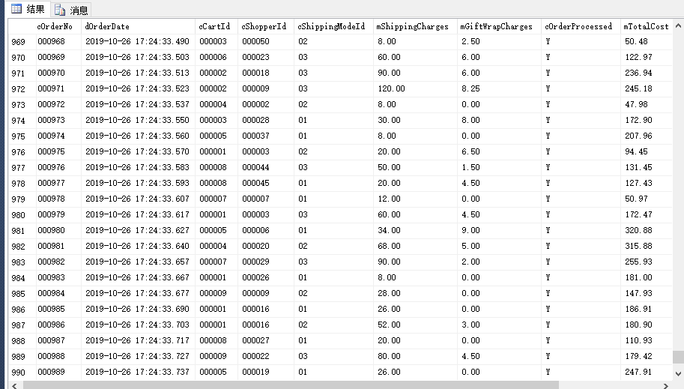

图1 orders新增1000条数据

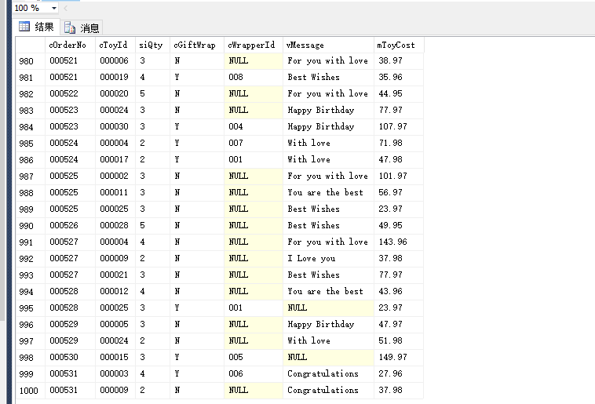

图2 orderdetail新增1000条数据

1. 更新PickofMonth表：

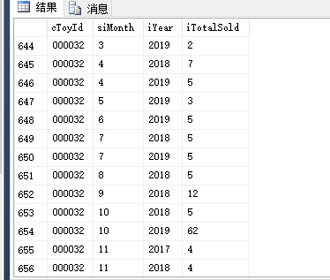

图3 pickofmonth更新

二、查询、更新数据库

1. 查找属于California和Florida州的顾客的名、姓和emailID：

select vFirstName,vLastName,vEmailId

from Shopper

/*查找条件为洲名为California或者Florida*/

where cState='California' or cState='Florida'

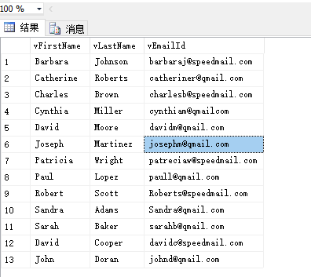

1. 查找定单号码、顾客ID，定单的总价值，并以定单的总价值的升序排列：

select cOrderNo,cShopperId,mTotalCost

from Orders

/*总价升序*/

order by mTotalCost asc

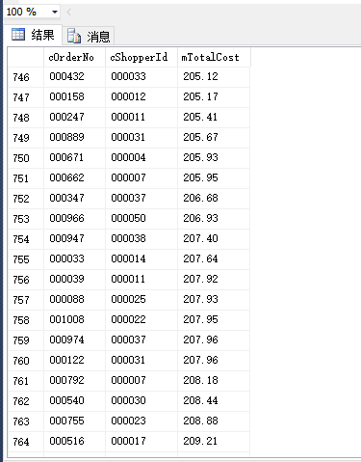

1. 查找在orderDetail表中vMessage为空值的行：

select *

from OrderDetail

/*vMessage为空时*/

where vMessage is null



1. 查找玩具名字中有“Racer”字样的所有玩具的基本资料：

select *

from Toys

/*Raser前后都可以为多个字符*/

where vToyName like '%Racer%'



1. 根据2016年的玩具销售总数，查找“Pick of the Month”玩具的前五名的ID:

/*用top5取出前5,sum计算总销售量*/

select top 5 cToyId,sum(iTotalSold) as total

from PickOfMonth

/*查找条件为年份是2016*/

where iYear='2016'

/*按照toyid分组销售总量*/

group by cToyId

/*按照销售量降序排列*/

order by total desc



1. 根据OrderDetail表，查找玩具总价值大于￥50的定单的号码和玩具总价值:

select cOrderNo,mToyCost

from OrderDetail

where mToyCost>50



1. 查找一份包含所有装运信息的报表，包括：Order Number, Shipment Date, Actual Delivery Date, Days in Transit:

/*用datediff函数求两段时间相差的天数*/

Select cOrderNo,dShipmentDate,dActualDeliveryDate,Days_in_Transit=datediff(day,dShipmentDate,dActualDeliveryDate)

from Shipment



1. 查找所有玩具的名称、商标和种类（Toy Name, Brand, Category）：

select vToyName,cBrandName,cCategory

from Toys,Category,ToyBrand

where Toys.cCategoryId=Category.cCategoryId and Toys.cBrandId=ToyBrand.cBrandId/*多表连接*/



1. 查找玩具的名称和所有玩具的购物车ID。如果玩具不在购物车中，也需在结果中出现：

select vToyName,cCartId

from Toys

/*用外连接查询，不符合条件的列会被填上null后返回到结果集*/

left outer join ShoppingCart

on Toys.cToyId=ShoppingCart.cToyId



1. 以下列格式查找所有购物者的名字和他们的简称：（Initials, vFirstName, vLastName）,例如Angela Smith的Initials为A.S：

/*用SUBSTRING方法可以求得字段的首字母*/

select (substring(vFirstName,1,1)+'.'+substring(vLastName,1,1)) as Initials,vFirstName,vLastName

from Shopper



1. 查找所有玩具的平均价格，并舍入到整数：

/*avg求平均值，round取整数*/

select round(avg(mToyRate),0) as AvgRate

from Toys



1. 查找所有购买者和收货人的名、姓、地址和所在城市，要求保留结果中的重复记录：

select a.vFirstName,a.vLastName,a.vAddress,a.cCity,b.vFirstName,b.vLastName,b.vAddress,b.cCity

from Shopper a,Recipient b,Orders c

where a.cShopperId=c.cShopperId and c.cOrderNO=b.cOrderNO



1. 查找没有包装的所有玩具的名称：

select vToyName

from Toys

where cToyId

/*子查询，当包装为空时*/

in (select cToyId from OrderDetail where cWrapperId is NULL)



1. 查找已收货定单的定单号码以及下定单的时间：

select cOrderNo,dOrderDate

from Orders where cOrderNo

/* dActualDeliveryDate非空时即为已收获状态*/

in (select cOrderNo from Shipment where dActualDeliveryDate is NOT NULL)



1. 查找一份基于Orderdetail的报表，包括cOrderNo,cToyId和mToyCost，记录以cOrderNo升序排列，并计算每一笔定单的玩具总价值：

select cOrderNo,cToyId,mToyCost

from OrderDetail

order by cOrderNo

compute sum(mToyCost) by cOrderNo

1. 查找从来没有下过订单的顾客：

select *

from Shopper

/*对两张表左连接，可以将shopper中没有对应orders的客户补全null*/

left join Orders

on Shopper.cShopperId=Orders.cShopperId

where Orders.cOrderNo is null



1. 删除“Largo”牌的所有玩具。

alter table Toys nocheck constraint all /*解除外键*/

alter table ShoppingCart nocheck constraint all

alter table OrderDetail nocheck constraint all

alter table PickOfMonth nocheck constraint all

delete

from Toys

where cBrandId=(select cBrandId from ToyBrand where cBrandName='Largo')

alter table Toys check constraint all /*恢复外键*/

alter table ShoppingCart check constraint all

alter table OrderDetail check constraint all

alter table PickOfMonth check constraint all

